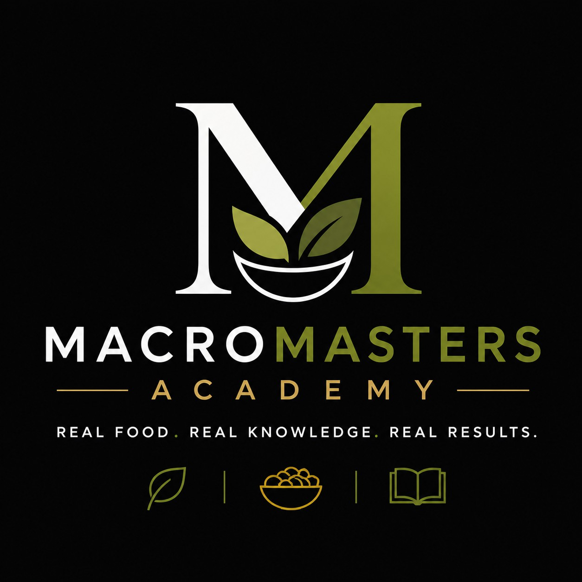
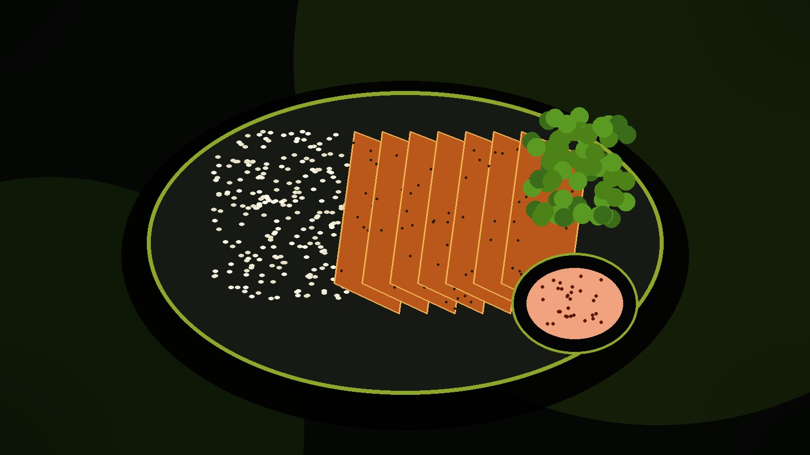

THEORETICAL GUIDE TO MACROS
labels, portions and smart recipe application
No ready-made recipes - only knowledge users can apply to any meal.

Fuel your body. Enjoy every bite.

INTRODUCTION

How to Use This Book
This book is designed as a theoretical guide for users of the MacroMasters Academy platform. Its goal is not to provide ready-made recipes, but to explain the logic behind every good meal: what calories are, what macros are, how to read a nutrition label, how to estimate a portion and how to adapt a recipe to a goal without making nutrition complicated.
When users understand the principles, every recipe becomes easier to use. They do not have to memorize rules; they understand why a meal contains chicken, yogurt, rice, oats, eggs, tuna, cheese or vegetables. They know when to increase energy, when to reduce calorie-dense additions, when to add protein and when a product is only marketed as "fit".
The guide is written for beginners, people who train, students, busy professionals and anyone who wants simpler nutrition. The tone is practical: scientific enough for the information to be accurate, but clear enough to be applied immediately.

Important: this is not individual medical advice, a therapeutic nutrition plan or a substitute for a doctor, nutritionist or dietitian. People with diabetes, eating disorders, kidney, liver, heart or gastrointestinal conditions, pregnancy or other medical conditions should follow the advice of a qualified professional.Important: this is not individual medical advice, a therapeutic nutrition plan or a substitute for a doctor, nutritionist or dietitian. People with diabetes, eating disorders, kidney, liver, heart or gastrointestinal conditions, pregnancy or other medical conditions should follow the advice of a qualified professional.

What the User Gets From This Book
- An understanding of calories and energy balance without complicated formulas.
- A clear explanation of protein, carbohydrates and fats.
- A practical system for reading labels and evaluating products.
- A way to apply recipes according to the goal: cut, bulk, maintenance or healthier habits.
- Better control of portions, sauces, add-ons and "hidden" calories.



INDEX
INDEX:
How to Use This Book 2
1. Calories: The Basis of Every Change 4
2. Macros: What They Really Mean 5
3. Protein: Satiety, Recovery and Meal Structure 6
4. Carbohydrates: Energy and Performance 7
5. Fats: Flavor, Hormones and Calorie Density 9
6. Fiber, Water and Micronutrients 10
7. How to Read a Nutrition Label 11
8. A Portion Is Not the Same as 100 g 13
9. Marketing Tricks on Packaging 14
10. How to Apply a Recipe Without Blindly Following It 15
11. Cut, Bulk and Maintenance 16
12. How to Assess Meal Quality 17
13. Meal Prep as a System, Not as a Recipe 18
14. The Most Common Beginner Mistakes 19
15. How to Use a Tracking App or Spreadsheet 21
16. How to Adapt a Meal to Training 22
17. How to Choose Foods in the Store 23
18. How to Maintain Consistency 24
19. Short Glossary of Terms 25
20. Final System: MacroMasters Rules 26
Sources and References 27
Knowledge That Changes the Way You Choose Food. 28
MacroMasters Academy 28

CHAPTER 1

Calories: The Basis of Every Change
Calories are a measure of energy. When food enters the body, it does not disappear; it is used for organ function, movement, training, thinking, recovery and maintaining body temperature. For that reason, calories are not the enemy. They are fuel. A problem appears only when intake is not aligned with the goal for a longer period of time.
Energy per MacronutrientProteinCarbohydratesFats4 kcal/g4 kcal/g9 kcal/gEnergy per MacronutrientProteinCarbohydratesFats4 kcal/g4 kcal/g9 kcal/gIf a person consistently consumes less energy than they burn, body weight usually decreases. If they consistently consume more energy than they burn, body weight usually increases. If intake is roughly equal to expenditure, weight tends to be more stable. This is the basis of energy balance, but in practice it is not enough to simply say "eat less" or "eat more". It also matters what those calories are made of, how filling the meal is and whether the person can repeat it.

Calories should not be judged by a single meal. The average intake across the day and week matters much more. One heavier meal does not destroy progress, just as one perfect meal does not solve everything. Results come from repetition, not perfectionism.
For a recipe user, the most important question is: what role does this meal play in my day? If it is a pre-workout meal, it may need more carbohydrates. If it is dinner during a cut phase, it may need more protein and vegetables and fewer calorie-dense additions. If the goal is bulk, the meal can be higher in energy, but it should still have a quality foundation.
When you understand calories, you do not have to fear food. You can eat in a tasty and smart way because you know where the energy is and how to fit it in.

CHAPTER 2

Macros: What They Really Mean
Macros are the three main groups of nutrients that provide energy: protein, carbohydrates and fats. Alcohol also provides energy, but it is not a macro used for planning quality nutrition. In the MacroMasters approach, macros work like a map: they show why one meal is better for satiety, another for energy and a third for gaining mass.
Protein and carbohydrates provide approximately 4 kcal per gram, while fats provide approximately 9 kcal per gram. This explains why a small amount of oil, butter, nuts or higher-fat cheese can significantly increase the calories in a meal. This does not mean fats are bad; it only means the amount matters.
When you look at a recipe, first identify its protein base. Then identify the energy source: is it rice, pasta, potatoes, oats, bread, fruit or fat? The third step is to assess satiety: does it contain fiber, volume, vegetables, fruit or a fermented dairy product such as Greek yogurt?
Macros are not meant to turn life into mathematics. They are meant to make decisions simpler. If you are hungry after a meal, it may not contain enough protein or volume. If you have no strength in training, it may not contain enough energy. If calories keep getting out of control, fats and sauces may be too high.
A good recipe is not only tasty. A good recipe has a clear function: it can be for a cut, bulk, maintenance, breakfast, a post-workout meal or meal prep.

CHAPTER 3

Protein: Satiety, Recovery and Meal Structure
Protein is the most important macro when a person wants better shape, stronger satiety and better meal structure. It participates in building and maintaining tissue, and it is especially important for people who train. In practice, protein is also the most common missing element among beginners: they consume enough calories, but their meals do not have a clear protein base.
A high-protein meal does not have to be boring. Chicken, turkey, tuna, salmon, lean beef, eggs, egg whites, cottage cheese, skyr and high-protein Greek yogurt can be combined in many ways. The difference between an ordinary meal and a smart meal is often whether the protein is clearly planned.
In a cut phase, protein helps a meal satisfy hunger with fewer calories. In a bulk phase, protein provides material for recovery and growth, but it should not be overdone to the point that it pushes out carbohydrates and energy. In maintenance, protein helps stabilize appetite.
On a label, it is useful to look at how much protein a product provides in relation to its calories. A product with 200 kcal and 20 g of protein is usually a better protein choice than a product with 450 kcal and 12 g of protein if the goal is definition. For bulk, both may have a place, but in different roles.
Protein powder can be a practical addition, but it is not required. It does not replace basic nutrition; it helps when there is little time or when making protein yogurt, porridge or dessert.

CHAPTER 4

Carbohydrates: Energy and Performance
- Carbohydrates are the main source of easily available energy for many activities. The brain and muscles often use them efficiently, especially when a person trains. For that reason, it is not wise to automatically remove them just because the goal is weight loss. A much better approach is portion control and choosing the right sources.
Potatoes, rice, oats, pasta, whole-grain bread, fruit and some legumes can be excellent sources of energy. Problems usually appear with liquid calories, sweets, snacks and products that combine a lot of sugar and fat, because they are easy to overeat.
- For training, it is especially useful to understand timing. A meal with carbohydrates a few hours before training can provide a better feeling of strength. After training, carbohydrates can help replenish energy stores, especially if the session was harder.
- On the label, look at total carbohydrates, sugars and fiber. High sugar is not automatically a problem if it comes from fruit in a normal portion, but a product with a lot of added sugar, little protein and little fiber often does not keep you full for long.
The biggest practical mistake is confusing raw and cooked weight. One hundred grams of raw rice has far more calories than one hundred grams of cooked rice, because cooked rice contains water. That is why recipes must clearly state whether the amount is measured raw or cooked.

CHAPTER 5

Fats: Flavor, Hormones and Calorie Density
- Fats are needed for health, flavor and absorption of vitamins A, D, E and K. They are not the enemy. The issue is that they are calorie-dense: they provide around 9 kcal per gram, so a small amount can significantly change total intake.
- Oil, butter, nuts, avocado, higher-fat cheeses, mayonnaise and fatty dressings can be part of nutrition, but they should not be estimated "by eye" when the goal requires more precision. One tablespoon of oil can have around 90 kcal, and two can already be similar to a small snack.
- For a cut, fats are usually not removed; they are controlled. For bulk, fats can help reach a higher calorie intake more easily, but food quality still matters. For maintenance, the goal is balance and consistency.
- A good trick is to replace part of high-fat sauces with Greek yogurt, mustard, spices, garlic, lemon or hot sauce. This keeps the meal tasty and creamy while keeping calories under control.
- On the label, pay attention to total fat and saturated fat. You do not need to panic because of a single number, but you should see the wider picture of the whole day.

CHAPTER 6

Fiber, Water and Micronutrients
Healthy nutrition is not only the sum of calories and macros. If someone hits protein and calories but has no vegetables, fruit, fiber or varied foods, the diet can still be poor. That is why the MacroMasters approach teaches not only "how much", but also "from where".
Fiber helps satiety and normal digestion. It is found in vegetables, fruit, oats, whole grains, legumes, seeds and nuts. If someone has not consumed enough fiber for a long time, it should be increased gradually while drinking enough water.

A model for applying a recipe without writing a recipeChoose a protein base.Add an energy source according to the goal.Add volume: vegetables, fruit or salad.Control sauces and fats because that is where calories escape most easily.Finally, match the portion to the calorie goal.A model for applying a recipe without writing a recipeChoose a protein base.Add an energy source according to the goal.Add volume: vegetables, fruit or salad.Control sauces and fats because that is where calories escape most easily.Finally, match the portion to the calorie goal.

Water is important for energy, concentration and training. Many people unknowingly consume calories through juices, sweetened coffees and drinks. Replacing liquid calories with water or sugar-free drinks is often the easiest first step.
Micronutrients are vitamins and minerals. Calcium is important for bones and muscles, iron for oxygen transport, potassium and magnesium for muscle function, vitamin C for normal immune function and B vitamins for energy metabolism.
The best meal does several things at once: it provides protein, energy, volume, flavor and useful micronutrients.

CHAPTER 7

How to Read a Nutrition Label
A nutrition label is a tool that gives users control. Instead of trusting the front of the package, a person can look at the numbers and make a better decision. In Europe, values are usually listed per 100 g or 100 ml, which makes it easy to compare products.
The first step is to check whether the data refers to 100 g or to a serving. The second step is calories. The third step is protein. Then look at carbohydrates, sugars, fats, saturated fats, fiber and salt. Finally, read the ingredients.

Mini example: real intake | Formula: value per 100 g x grams eaten / 100 = real intake

Item | Per 100 g | Serving 250 g | What it means
Energy | 120 kcal | 300 kcal | Do not read only 100 g.
Protein | 10 g | 25 g | Good contribution to the meal.
Carbs | 14 g | 35 g | Energy, depends on the goal.
Sugars | 3 g | 7.5 g | Check the context.
Fats | 3 g | 7.5 g | Calories rise quickly.
Salt | 0.5 g | 1.25 g | Salt adds up during the day.

Ingredients are most often listed from the largest amount to the smallest. If sugar, syrup or oil is among the first ingredients, the product may be higher in calories than it seems. If a product claims to be high-protein, check whether it really has enough protein per serving.
For products advertised as healthier, the most common traps are small serving sizes, high calorie density, lots of added sugar, little protein or a lot of fat. None of these elements automatically means the product is forbidden, but it changes its role.
The goal is not for label reading to become an obsession. The goal is for the user to know what they are buying and how to fit the product into their day.

CHAPTER 8

A Portion Is Not the Same as 100 g
Most nutrition mistakes do not come from not knowing what is healthy, but from misjudging quantity. A person knows oatmeal is good, but does not know whether they are eating 40 g or 120 g of oats. They know nuts are healthy, but do not realize that 30 g and 100 g are not the same meal.
The formula is simple: multiply the value per 100 g by the amount you eat and divide by 100. If a product has 120 kcal per 100 g and you eat 250 g, the intake is 300 kcal. The same logic applies to protein, fat, carbohydrates, sugar and salt.
The serving size listed by the manufacturer is not necessarily the portion you eat. Sometimes the serving is unrealistically small, especially with cereals, granola, snacks, bars or spreads. That is why it is important for the user to measure their real amount at least in the beginning.

When the eye learns portions, measuring can become more relaxed. But for a beginner, it is very useful to measure basic foods for a few days. This should not be punishment, but education.

Recipes on the platform should be applied through an understanding of portions. If a meal is too heavy, reduce the energy source or sauce. If it is too light, add rice, potatoes, oats or a healthy fat.

CHAPTER 9

Marketing Tricks on Packaging
The front of the package is advertising. The back of the package is information. Words such as "fit", "protein", "light", "natural", "no added sugar", "whole grain" or "high protein" can be useful, but they are not enough to automatically make a product a good choice.

Quick filter: does the product fit your goal?Quick filter: does the product fit your goal?A protein bar may have more protein than a regular bar, but it can still contain many calories. Granola may look healthy, but it often contains oil or syrup. Fruit yogurt may seem light, but it can have more sugar and less protein than plain Greek yogurt.

Question | Cut | Bulk | Maintenance
Does it have protein? | Advantage. | Advantage. | Advantage.
How many calories does it contain? | Control it. | Can be higher. | Moderate balance.
Does it satisfy? | Important. | Less critical. | Important.
Does it have fiber? | Helps. | Helps digestion. | Helps.

A light product means something has been reduced compared with the standard version, but it does not have to mean low-calorie. No added sugar does not mean no calories. Whole grain does not automatically mean good for a cut. Keto does not automatically mean healthy. High protein does not automatically mean enough protein.
The real question is not: "Is this healthy?" The real question is: "Does this product fit my goal, portion and the rest of my day?" The same product can be good for bulk but a poor choice for a stricter cut.
MacroMasters rule: read the label first, then the ingredients, and only then believe the marketing.

CHAPTER 10

How to Apply a Recipe Without Blindly Following It
A user should not depend on whether a recipe is written perfectly for them. They should know how to adapt it. Every recipe has a structure: a protein base, an energy source, additions for volume, sauce and spices. Once that structure is visible, the recipe becomes easy to change.
If the goal is a cut, protein is protected first. Then the most calorie-dense part is reduced: oil, cheese, butter, spread, a large portion of rice or pasta. Instead, vegetables, salad, zucchini, cucumber or yogurt sauce are added. This keeps the meal large and tasty, but lighter.
If the goal is bulk, the solution is not simply to add unhealthy food. It is better to increase a quality energy source: rice, potatoes, oats, pasta, bread, banana or a little olive oil. Protein stays stable, and total calories increase.
If the goal is maintenance, the recipe is used as a middle ground. The portion is not extreme, the sauce is controlled and the meal has a balance of protein, energy and micronutrients.
A well-applied recipe is one that fits the user's life. If preparation takes too long, the meal will not be repeated. If it does not taste good, consistency drops. That is why flavor is part of the strategy, not a luxury.

CHAPTER 11

Cut, Bulk and Maintenance
- Cut means a person wants to reduce body weight or body fat while preserving energy and muscle. The main logic is a moderate calorie deficit, enough protein, plenty of filling foods and control of calorie-dense additions. Extreme hunger is not a good system for long-term consistency.
- Bulk means a person wants to increase body weight, usually with strength training. The main logic is a calorie surplus, enough protein and enough carbohydrates for training. Bulk does not mean eating anything without control; the goal is progress, not only a higher number on the scale.

Goal | What to increase | What to control | Main focus
Cut | Protein and vegetables | Oils and sweets | Satiety with fewer kcal
Bulk | Carbs and calories | Junk without protein | Energy and growth
Maintenance | Consistency | Extremes and overeating | Stable habits

Maintenance is often the most important phase, because it teaches the user not to move from one extreme to another.
Recipes in all three phases differ mostly by the portion of energy and fat. Protein is relatively stable. Vegetables and fiber are useful in every phase. Sauces and oils are adjusted to the goal.
The best plan is the one a person can repeat. If the system is too difficult, it will not last. If it is too loose, it will not produce results. Balance is key.

CHAPTER 12

How to Assess Meal Quality
Meal quality is not only calorie value. Two meals can have 600 kcal, but one may provide protein, fiber and micronutrients, while the other provides mostly sugar and fat. That is why it is important to look at the function of the meal.
- First question: does the meal have enough protein for its size?
- Second: does it have an energy source that matches the goal?
- Third: does it have volume and micronutrients? Fourth: is the sauce controlled? Fifth: is it tasty and realistic to repeat?
A meal without protein often leads to quick hunger. A meal without energy can be a problem before training. A meal without fiber can be less filling. A meal with too much oil or sauce can be much higher in calories than it looks.
A quality meal does not have to be expensive. Chicken, eggs, tuna, yogurt, potatoes, rice, oats, vegetables and fruit can cover most needs. Luxury food is not required for results.
The user should learn to view a meal as a system. If the system has good structure, the result is easier to maintain.

CHAPTER 13

Meal Prep as a System, Not as a Recipe
Meal prep does not mean you have to eat the same food for seven days. It means reducing the number of decisions in advance. When the protein base, energy source and sauce are ready, a meal can be assembled in a few minutes.
The most practical system is to prepare separately: protein, carbohydrates, vegetables and sauce. For example, you do not need a finished recipe; it is enough to know you have prepared chicken, cooked rice, yogurt sauce and vegetables. The combination is then adjusted to the goal.
- For a cut, meal prep helps you avoid impulsive meals when you are hungry.
- For bulk, it helps you eat enough calories because you have prepared portions in advance.
- For maintenance, it helps nutrition stay organized despite obligations.
It is important to think about food safety. Cooked food should be stored in clean, sealed containers and cooled on time. If food smells strange, has changed texture or has been stored too long, do not take the risk.
Good meal prep is flexible. It is not a punishment, but a tool that saves time and reduces stress.

CHAPTER 14

The Most Common Beginner Mistakes
- The first mistake is skipping protein. A person eats a pastry, juice and sweets, then wonders why they get hungry quickly.
- The second mistake is believing that healthy automatically means low-calorie. Nuts, oil, avocado and butter can be healthy, but they are calorie-dense.
- The third mistake is not reading the portion. If the label says 100 g and the package has 300 g, real intake must be calculated.
- The fourth mistake is drinking calories through juices, sweetened coffee and beverages.
- The fifth mistake is going extreme. People often start too strictly, remove everything they enjoy and then give up. It is much better to build a system that is a little less perfect, but can be repeated.
- The sixth mistake is expecting one product to solve everything. Protein powder, a protein bar or an expensive supplement is not the foundation. The foundation is meals, portions, sleep, training and consistency.
- The seventh mistake is comparing yourself with others. Your goal, appetite, schedule and training are not the same as another person's. That is why recipes should be used as a tool, not as a strict copy of someone else's life.

CHAPTER 15

How to Use a Tracking App or Spreadsheet
Tracking calories and macros can be useful, but it does not have to last forever. For a beginner, it is like learning a language. During the first few weeks, you learn what portions mean, how many calories oil has, how much protein yogurt contains and how large a real portion of rice is.
If you use an app, check whether you are entering raw or cooked weight. Enter the exact amount and do not forget additions: oil, sauce, cheese, spreads, nuts, honey and drinks. The most common mistakes are exactly in the things that seem "small".
You should not obsess over perfect precision. Labels have tolerances, cooking changes the water content of food and the body is not a calculator. The goal of tracking is better estimation, not perfection.
Once you learn the basic foods, you can move to a more flexible system: measure only calorie-dense additions and protein sources, and estimate the rest. This is often more sustainable.
Tracking is a tool. If it causes stress or leads to extreme behavior, it should be simplified and, if necessary, discussed with a qualified professional.

CHAPTER 16

How to Adapt a Meal to Training
A pre-workout meal should support performance, not burden the stomach. Many people do well with a combination of carbohydrates and protein a few hours before training. Too much fat right before training can bother some people because it digests more slowly.
A post-workout meal does not have to be magical within the first ten minutes. It is more important to have enough protein, energy and fluids during the day. Still, it is practical to eat a meal with protein and carbohydrates after training, especially if the workout was harder.
For a cut, meals around training can help maintain strength and mood. For bulk, meals around training are an opportunity to consume a larger share of calories. For maintenance, the goal is stable energy without overeating.
If you train early, a simpler meal or shake may be practical. If you train late, dinner should be filling but not too heavy. It all depends on the person.
A recipe should serve the schedule, not the schedule serve the recipe. If a meal is not practical for your day, it should be adapted.

CHAPTER 17

How to Choose Foods in the Store
The store is where decisions are made in advance. If you have good foods at home, you are more likely to eat better. If you mostly buy sweets, snacks and ready-made calorie-dense products, you rely on willpower when you are hungry, and that rarely works long term.
Good shopping starts with a protein base: chicken, turkey, eggs, tuna, fish, cottage cheese, Greek yogurt, skyr or lean meat. Then come energy sources: rice, potatoes, oats, pasta, bread, fruit. Then vegetables, salad, spices and sauces.
For every product, check three things: calories, protein and ingredients. If you are buying a sauce, check calories per serving. If you are buying yogurt, check protein and sugar. If you are buying granola, check fats and sugars.
Not everything has to be the most expensive. Often, the simplest foods are the best. The problem is not plain rice, potatoes or eggs. The problem is when a person has no plan and keeps buying impulsively.
Buy foods that can be combined. This gives flexibility without constantly needing to look for new recipes.

CHAPTER 18

How to Maintain Consistency
- Consistency is not the same as perfection. Perfection lasts briefly; consistency lasts a long time. A person who follows the plan 80% of the time usually progresses better than a person who does everything perfectly for three days and then gives up.
- The best system is the one that fits taste, time, budget and goal. If meals are not enjoyable, the user will not stick with them. If they are too expensive, they will not be repeated. If they take an hour to prepare, they will not fit a busy schedule.
- A plan should leave room for normal life. Birthdays, going out, school, work and family meals are part of reality. One meal outside the plan does not ruin the result. The problem appears when there is no return to the system.
- It is useful to have several reliable meals you can always make. These are not recipes in this book, but patterns: protein + energy + volume + sauce. When you know the pattern, you can improvise.
- Consistency is built through small wins: a better breakfast, more protein, fewer liquid calories, reading the label, food prepared for tomorrow. That is real progress.

CHAPTER 19

Short Glossary of Terms
- A calorie is a measure of energy from food. Macros are protein, carbohydrates and fats. Protein is the macro that helps build and maintain tissue and contributes to satiety. Carbohydrates are an important source of energy, especially for training. Fats are calorie-dense, but important for health and flavor.
- A nutrition label is the table on a product that shows energy and nutrient values. A portion is the amount you actually eat, while 100 g is used for comparing products. Ingredients are the list of foods in the product, usually ordered from the most present to the least present.
- Cut is the phase of reducing body weight or body fat with controlled calorie intake. Bulk is the phase of increasing body weight with training and higher energy intake. Maintenance is the phase of stable intake and habits.
- Meal prep is a food system prepared in advance. It does not have to be the same meal every day. It can be a prepared base that is combined in several ways.
- Calorie density means how many calories a food has in a small amount. Oil, nuts, butter and cheese can be very dense. Vegetables and some fruits often have lower calorie density and higher volume.

CHAPTER 20

Final System: MacroMasters Rules
The MacroMasters approach can be summarized in several rules. First: every main meal should have a clear protein base. Second: the energy source is chosen according to the goal and training. Third: sauces and fats are controlled because they quickly change calories. Fourth: the label is read before the marketing is believed.
Fifth: the portion is what you actually eat, not what the package lists as an ideal serving. Sixth: a recipe is not a law, but a tool. If you understand the structure, you can adapt it without losing flavor.
Seventh: results come from a system you can repeat.
This book is not meant to make the user obsessed with food. It is meant to remove confusion. When you know how calories, macros and labels work, you have the freedom to choose more wisely.
The best nutrition is not the one that lasts seven days. The best nutrition is the one that helps you live better, train better, feel better and repeat it without a constant feeling of punishment.

Fuel your body. Enjoy every bite.

SOURCES

Sources and References

This book is written as educational material based on generally accepted principles of healthy nutrition, label reading and energy balance.
The listed sources serve as support for checking concepts and rules, not as an individual nutrition plan.
- World Health Organization. (2026). Healthy diet. WHO fact sheet. Emphasizes the importance of a varied diet, vegetables, fruit, fiber and limiting excessive intake of salt, sugar and unhealthy fats.
- U.S. Food and Drug Administration. (2024). How to understand and use the Nutrition Facts Label. Explains serving size, calories, nutrients and % Daily Value on the label.
- European Commission. Food information to consumers - nutrition labelling. Explains the mandatory nutrition declaration for most prepacked food products in the EU: energy, fat, saturated fat, carbohydrates, sugars, protein and salt.
- Harvard T.H. Chan School of Public Health. The Nutrition Source - Healthy Eating Plate. A useful model for understanding the structure of a balanced meal.
- NHS. The Eatwell Guide. A practical guide to balancing food groups across the day or week.

Note: For people with medical conditions, allergies, specific treatments or a history of eating disorders, individual recommendations should be provided by a qualified professional.Note: For people with medical conditions, allergies, specific treatments or a history of eating disorders, individual recommendations should be provided by a qualified professional.

Knowledge That Changes the Way You Choose Food.

This guide was created to explain the logic of nutrition without extreme rules, blind recipe-following or confusing marketing.

When you understand calories, macros, portions and labels, every meal becomes clearer. Then a recipe is not a limitation, but a tool you can adapt to your goal.

MacroMasters Academy

Fuel your body. Enjoy every bite.

